**Zomato Project Newton School**

**OBJECTIVE QUESTIONS:**

1. **What is the total number of tables present in the data?**

The total number of tables present in the data are 2 Tables (Raw data and country description.

1. **What is the total number of attributes present in the data?**

The total number of attributes present in the data is20 in raw data and 6 in Country description and 20 is in modified data.

1. **How many categorical columns are there in the data?**

Based on the attributes, the categorical columns could be:

In Raw Data 14 columns

1. Restaurant Name
2. Country Code
3. City
4. Address
5. Locality
6. Locality Verbose
7. Cuisines
8. Currency
9. Has Table booking
10. Has Online delivery
11. Is delivering now
12. Switch to order menu
13. Price range
14. Rating

In Country description 4 columns

1. Country Code
2. Country Name
3. Currency
4. Currency Symbol
5. **The data consists of some inconsistent and missing values so ensure that the data used for further analysis is cleaned.**

i) The missing values are found in the **Average_Cost_for_two_Updated** attribute column, where the missing values are only from the **Price_range** value of **1** and from the countries India and USA.

Therefore, **AverageIFS()** Function is used to find the missing values, where we select the **CountryName** columnas **range_criteria_1** with **India & USA** as **criterion_1** and for **range_criteria_2** we select **Price_range** column with **criterion_2** value as **1** and finally the **average_range** as **Average_Cost_for_two_Updated** column.

i.e. =AVERAGEIFS($AC:$AC,$D:$D,"India",$R:$R,1)

=AVERAGEIFS($AC:$AC,$D:$D,"UnitedStatesof America",$R:$R,1)

The average value appears to be **Rs. 274 for India and Rs. 774 for USA.** To feed the missing values with 274 and 774 for the respective countries, we used the **Filter** function in **Average_Cost_for_two_updated** attribute to get the missing values, and used the Fill_Handleoption to insert the averages.

ii) Additionally, we noted missing values in attributes such as **Longitude**, **Latitude**, and **Cuisines**. While these missing values were present, they were not expected to significantly impact our analysis. Therefore, we decided to neglect them, as the "**City**" attribute could serve as a **suitable substitute** for missing longitude and latitude values. Furthermore, the small number of missing values in the "**Cuisine**" attribute (only 9) were marked **negligible**.

1. **Using the LookUp functions, fill up the countries in the original data using the country code.**

Attribute **‘CountryName’** column has been inserted in the original data and using the **VLOOKUP()** function the country name has been identified by matching the country code with the help of ‘*Country Description’* *worksheet.*

i.e. =VLOOKUP ($C2, 'Country Description'!$A$1:$B$16, match ('Country Description'!$B$1, 'Country Description'!$1:$1, 0), 0)

1. **Create a table to represent the number of restaurants opened in each country.**

|  |  |
| --- | --- |
| *Country Name* | COUNT of Restaurant |
| India | 8652 |
| United States of America | 434 |
| United Kingdom | 80 |
| United Arab Emirates | 60 |
| South Africa | 60 |
| Brazil | 60 |
| New Zealand | 40 |
| Turkey | 34 |
| Australia | 24 |
| Philippines | 22 |
| Indonesia | 21 |
| Sri Lanka | 20 |
| Singapore | 20 |
| Qatar | 20 |
| Canada | 4 |
| **Grand Total** | **9551** |

1. **Also, the management wants to look at the number of restaurants opened each year, so provide them with something here.**

To represent the number of restaurants opened in each year created pivot table that displays the number of restaurants opened in each year.

|  |  |
| --- | --- |
| *Datekey-Opening - Year* | COUNT of Restaurant |
| 2010 | 1080 |
| 2011 | 1098 |
| 2012 | 1022 |
| 2013 | 1061 |
| 2014 | 1051 |
| 2015 | 1024 |
| 2016 | 1027 |
| 2017 | 1086 |
| 2018 | 1102 |
| **Grand Total** | **9551** |

1. **What is the total number of restaurants in India in the price range of 4?**

**Sol:** Total number of restaurants in India in the price range of 4:

|  |  |  |
| --- | --- | --- |
| *Country Name* | *Price_range* | COUNT of Restaurant |
| India | 4 | 388 |

1. **What is the average number of voters for the restaurants in each country according to the data?**

The Average number of voter for the restaurants in each country according to data are as follows :

|  |  |
| --- | --- |
| *Country Name* | AVERAGE of Votes |
| Indonesia | 772.10 |
| United Arab Emirates | 493.52 |
| Turkey | 431.47 |
| United States of America | 428.22 |
| Philippines | 407.41 |
| South Africa | 315.17 |
| New Zealand | 243.03 |
| United Kingdom | 205.49 |
| Qatar | 163.80 |
| Sri Lanka | 146.45 |
| India | 137.21 |
| Australia | 111.42 |
| Canada | 103.00 |
| Singapore | 31.90 |
| Brazil | 19.62 |
| **Grand Total** | **156.91** |

1. **Calculate the average rating for all the restaurants that have price_range < 4 and provide online delivery. Use only the “IF” function, Logical Operators, and Aggregation functions to solve this problem. [Note: Don’t use Conditional aggregation in this question]**

We get the value of **3.27381151** as average by using the below mentioned logic**: =AVERAGE(IF(('Raw Data'!$S$2:$S$9552<4)*('Raw Data'!$P$2:$P$9552="Yes"),'Raw Data'!$W$2:$W$9552))** as per Raw file.

1. **Using Conditional formatting, highlight the rows of restaurants that are located in the countries or cities that you’ve suggested to the management for opening new restaurants.**

* The count of restaurants for each city has been taken into account for the attribute **Average_Cost_for_two_Updated** under the condition of values ranging between **100 to 500**.
* After analysing the condition for Average_Cost_for_two attribute, we have taken the restaurant's count **less than or equal to 10** into consideration for suggesting the management to open new restaurants.
* We used conditional formatting to highlight the rows for the restaurant’s count less than or equal to 10 by feeding a custom formula in the format rules tab.
* To view the highlighted city or country, we can *filter* any attributes by giving the condition filter by colour.

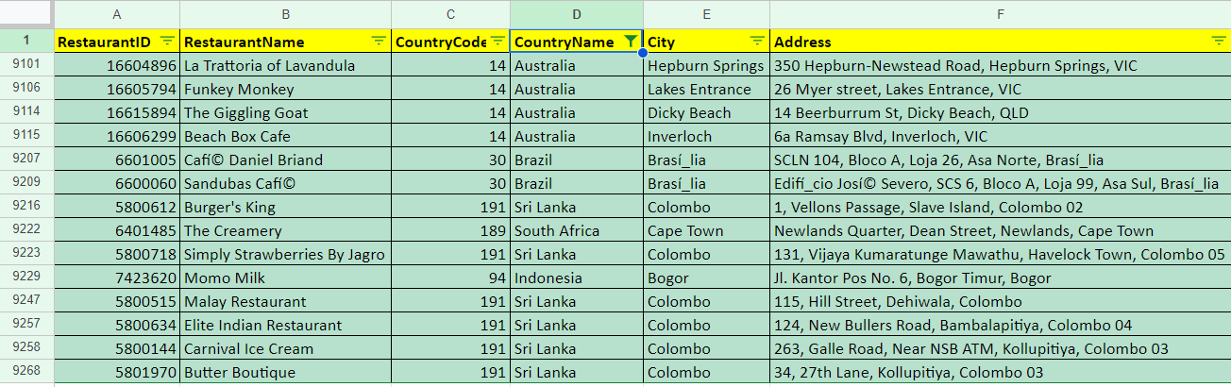

1. **Create a new customised price column that consists of the abbreviation/symbol of the currency along with the Average_cost_for_two value. [Use string operations to do this task]**

First we have to separate the currency symbol from the data of the currency attribute. For that we used **String()** Functions.

i.e=left(right(L2,(len(L2)-search("(",L2))),search(")",right(L2,len(L2)-search("(",L2)-1)))

After separating the currency symbol, we used the **Concatenate()** function to join two strings of *Currency_Symbol* attribute and *Average_cost_for_two* attribute.

i.e. =CONCATENATE(T2," ",S2)

1. **How can you create an array formula in Excel or Google Sheets to count the number of restaurants listed that do not offer online delivery, are in the lowest price range, and have an average cost for two people less than or equal to 250 Indian Rupees?**

The count of the number of restaurants listed that do not offer online delivery, are in the lowest price range, and have an average cost for two people less than or equal to 250 Indian Rupees is 1685.

**=ArrayFormula (count (if (($N:$N="No") * ($Q:$Q=1) * ($AB:$AB<= 250), $A:$A)))**

Using the above syntax, we are able to find the count of the number of restaurants which do not offer online delivery, are in the lowest price range and also have an average_cost_for_two people is less than or equal to 250 Indian Rupees by using an ArrayFormula().

**The Count of Restaurants for the above use case is:**

**1676**

**SUBJECTIVE QUESTIONS:**

1. **Suggest a few countries where the team can open newer restaurants with lesser competition. Which visualisation/technique will you use here to justify the suggestions?**

**(i) By Least Number of Restaurants:**

We used **Pivot Table** and **Column Chart** as visualization techniques, in order to suggest a few countries where the team can open newer restaurants with lesser competition with criteria where countries have the least number of restaurants.

We have selected the countries which have the least number of restaurants **(i.e. less than 25)**, so that there will be less competition when the management opens new restaurants.

The following are the countries with least number of restaurants:

* Canada
* Qatar
* Singapore
* Sri Lanka
* Indonesia
* Philippines
* Australia

**(ii) By Least Number of Ratings:**

We used **Pivot Table** and **Column Chart** as visualization techniques, in order to suggest a few countries where the team can open newer restaurants with lesser competition with criteria where the countries have less ratings.

We have selected the countries which have the least average ratings **(i.e. less than 4)**, so that there will be less competition when the management opens new restaurants.

The following are the countries with least average ratings:

* India
* Canada
* Singapore
* Australia
* Brazil
* Sri Lanka

**(iii) By Economical Average_Cost_for_two:**

We used **Pivot Table** and **Column Chart** as visualization techniques, in order to suggest a few countries where the team can open newer restaurants with lesser competition with criteria where the countries have economical average cost for two members.

We have selected the countries which have the least average cost for two **(i.e. less than Rs.2000)**, so that there will be less competition when the management opens new restaurants.

The following are the countries with least average ratings:

* Turkey
* India
* Sri Lanka
* Australia
* Indonesia
* South Africa

**"After analyzing these three conditions, we have arrived at our recommendations for countries to consider for opening new restaurants”. These countries are:**

* **Canada**
* **Sri Lanka**
* **Indonesia**
* **Australia**
* **Turkey**

1. **Come up with the names of States and cities in the suggested countries suitable for opening restaurants.**

Cities from the suggested countries have been selected based on the following criteria: having the least number of restaurants, ratings less than 3.7, and an average cost for two less than 2000.

|  |  |
| --- | --- |
| ***Country Name*** | ***City*** |
| **Australia** | Armidale |
|  | Balingup |
|  | Dicky Beach |
|  | Flaxton |
|  | Forrest |
|  | Inverloch |
|  | Lorn |
|  | Macedon |
|  | Mayfield |
|  | Montville |
|  | Penola |
|  | Phillip Island |
|  | Victor Harbor |
| **Canada** | Chatham-Kent |
|  | Consort |
|  | Yorkton |
| **Indonesia** | Bogor |
|  | Jakarta |
|  | Tangerang |
| **Sri Lanka** | Colombo |
| **Turkey** | Ankara |
|  | ÛÁstanbul |

1. **According to the countries you suggested, what is the current quality regarding ratings for restaurants that are open there?**

* In the suggested countries for opening new restaurants, **Turkey** and **Indonesia** lead with an average rating of 4.3 each.
* **Canada** received the lowest average rating of 3.6.
* **Sri Lanka** has an average rating of 3.9, while **Australia** slightly trails behind with a rating of 3.7.

|  |  |
| --- | --- |
| *Country Name* | AVERAGE of Rating |
| Canada | 3.6 |
| Australia | 3.7 |
| Sri Lanka | 3.9 |
| Indonesia | 4.3 |
| Turkey | 4.3 |

**Insights:**

* **Top Performers**:

**Turkey and Indonesia** stand out with an average rating of **4.3**, indicating a generally high level of customer satisfaction for restaurants in these countries.

* **Lowest Rating:**

**Canada** has the lowest average rating of **3.6**, which may suggest issues related to the quality of restaurants or customer expectations that aren’t being met. It could also reflect a more competitive market where customers are more critical or have higher standards for restaurants.

* **Moderate Ratings**:

**Sri Lanka** and **Australia** have moderate average ratings of **3.9** and **3.7** respectively. These ratings suggest that there is room for improvement, but restaurants in these countries are still performing reasonably well.

**Recommendations:**

* **Focus on High-Rating Countries**:

Given that Turkey and Indonesia have the highest average ratings, these countries could be strategic locations to **expand new restaurants**. Their high ratings suggest a strong, positive market sentiment that could support new ventures

* **Opportunity in Low-Rating Countries**:

While **Canada** has the lowest rating, this presents an opportunity for improvement. Zomato could work with restaurant partners in Canada to **improve the quality of service and offerings**, ensuring better customer experiences

* **Enhance Presence in Sri Lanka and Australia**:

Although **Sri Lanka** and **Australia** have moderate ratings, there’s potential to enhance Zomato’s market presence through **customer feedback-driven enhancements** and **strategic partnerships** with highly rated local restaurants.

1. **Also, what is the current expenditure on food in the suggested countries, so we can keep our financial expenditure in control?**

The current expenditure on food for an average of two persons in all countries is listed below:

|  |  |
| --- | --- |
| *Country Name* | AVERAGE of Average_Cost_for_two_Updated |
| Turkey | 219 |
| India | 624 |
| Sri Lanka | 641 |
| Australia | 1313 |
| Indonesia | 1490 |
| South Africa | 1855 |
| United States of America | 2184 |
| Canada | 2219 |
| Brazil | 2234 |
| New Zealand | 3520 |
| United Arab Emirates | 3756 |
| United Kingdom | 5049 |
| Qatar | 5095 |
| Singapore | 9649 |
| Philippines | 9802 |

The current expenditure on food for an average of two persons in the suggested countries is listed below:

|  |  |
| --- | --- |
| *CountryName* | AVERAGE of Average_Cost_for_two_Updated |
| Turkey | 219 |
| Sri Lanka | 641 |
| Australia | 1313 |
| Indonesia | 1490 |
| Canada | 2219 |

The above table has been plotted in a Bar Graph

**Insights:**

**Varied Expenditure Levels**:

* The **average cost for two** persons varies significantly across the suggested countries, with **Turkey** having the lowest cost at **219**, and **Canada** being the highest at **2219**.

**Affordable Markets**:

* **Turkey** and **Sri Lanka** have relatively low average dining costs of **219** and **641** respectively, making them the most affordable among the suggested countries.

**Mid-Range Markets**:

* **Australia** and **Indonesia** have moderate dining costs of **1313** and **1490** respectively. While these are higher than Turkey and Sri Lanka, they still represent a middle ground compared to more expensive countries like Canada.

**High-Cost Market**:

* **Canada** has the highest average cost for two persons at **2219**, indicating a relatively high expenditure on dining compared to the other countries in the list.

### **Recommendations:**

1. **Leverage Affordable Markets (Turkey, Sri Lanka)**:
   * In **Turkey** and **Sri Lanka**, where the dining costs are lower, Zomato could focus on **targeting the mass market**. These countries provide opportunities for volume-based growth, where the lower cost of dining can attract a larger customer base.

**2. Optimize Pricing in Mid-Range Markets (Australia, Indonesia)**

* **Australia** and **Indonesia** have moderate costs, and Zomato should consider strategies to **optimize pricing** for both mid-range and premium restaurant segments. These countries may also be ideal for **dynamic pricing models**, where Zomato could offer deals and discounts to attract a wider audience

**3. Monitor Cost Trends**:

* In countries like Canada and Indonesia, where dining costs are higher, Zomato should **carefully monitor cost trends** to avoid overspending on partnerships or operations that may not yield sufficient returns.

**4. Adjust Marketing and Promotions**:

* Given the cost variations, Zomato should consider **adjusting marketing strategies** in each country. For lower-cost countries, focus on **mass promotions and deals** that cater to a wider audience.

1. **Come up with the names of restaurants from the recommended states that are our biggest competitors and also those that are rated in the lower brackets, i.e. 1-2 or 2-3.**

i) We used the **healthy rating** of each restaurant to identify the names of restaurants for the suggested countries/states that could be our possible competitor.

Restaurants that are our biggest competitors in suggested countries: 72 in total are above 4.0 Rating.

|  |  |
| --- | --- |
| **Restaurant Name** | **Rating** |
| Mainland China Restaurant | 4.9 |
| Ooma | 4.9 |
| Ministry of Crab | 4.9 |
| Spiral - Sofitel Philippine Plaza Manila | 4.9 |
| Talaga Sampireun | 4.9 |
| Sushi Masa | 4.9 |
| Talaga Sampireun | 4.9 |

* Restaurants that are rated below 3: Only 7 found.

|  |  |
| --- | --- |
| **Restaurant Name** | **Rating** |
| Pier 70 | 2.6 |
| Consort Restaurant | 3 |
| Makansutra Gluttons Bay | 3 |
| Poets Cafe | 2.4 |
| Star Buffet | 2.9 |
| Elite Indian Restaurant | 2.4 |
| Queen's Cafe | 2.5 |

**Insights:**

* **Highly Rated Competitors**:

There are **72 restaurants** in total that have ratings above **4.0**, with some restaurants having extremely high ratings (4.9). For instance, **Mainland China Restaurant, Ooma, Ministry of Crab, Spiral, Talaga Sampireun**, and **Sushi Masa** are all rated **4.9**, marking them as the **biggest competitors** due to their strong customer satisfaction and high-quality dining experiences.

* **Competitive Landscape**:

These high-rating restaurants likely offer premium services, top-quality food, and exceptional dining experiences, which appeal to discerning customers. These competitors may have established a loyal customer base,

* **Low-Rated Restaurants**:

There are only **7 restaurants** with ratings below **3**. These include **Pier 70, Poets Cafe, Star Buffet**, and others. These lower-rated restaurants likely struggle with factors such as **food quality, service issues, or customer experience** and thus have received unfavorable ratings.

* **Opportunity in Low-Rated Segment**:

The small number of low-rated restaurants in the suggested countries shows that **most restaurants are performing well**. However, these few low-rated establishments represent an opportunity for Zomato to highlight the **quality assurance** and **value-added services** that can help restaurants improve their performance.

**Recommendations:**

* **Benchmark Against Highly Rated Competitors**:

To stay competitive with restaurants like **Mainland China Restaurant, Ooma, and Ministry of Crab**, Zomato should conduct a **competitive analysis** of these highly rated restaurants to understand what drives their success. This could include evaluating their **menu offerings, customer service strategies, and marketing efforts**.

* **Leverage Partnerships with High-Rated Restaurants**:

**Collaborate with highly rated restaurants** like those mentioned to drive mutual benefits. Zomato could offer exclusive promotions, discounts, or marketing campaigns that benefit both the platform and these top competitors, increasing customer traffic to these restaurants through the Zomato app.

* **Assist Low-Rated Restaurants**:

Partner with the low-rated restaurants (those rated below 3) to **improve their ratings**. Zomato could offer them consultation services, including **improvement strategies in food quality, customer service training, or operational efficiency**

* **Promote Lower-Rated Competitors with Exclusive Deals**:

For the **lower-rated restaurants**, Zomato can offer **exclusive deals or discounts** to help attract customers and improve their ratings through **increased foot traffic** and better customer engagement

1. **Which cuisines should we focus on in the newer restaurants to get better feedback? Does the choice of cuisines affect the restaurant ratings?**

**Yes**, the choice of **cuisines** can indeed **impact the success, feedback and ratings** of a restaurant. The data shows that **Italian** and **Cafe Shop** cuisines are popular across multiple countries and tend to receive higher average ratings, making them strong candidates for new restaurants.

Cuisine preferences vary among individuals and they are influenced by factors such as:

* Local Demographics
* Diversity of Menu
* Current Culinary Trends
* Competitor Analysis
* Quality of Ingredients, etc.

### Approach:

**Analyze the Popularity of Cuisines**:

* + Look at the **frequency** of different cuisines across the suggested countries and determine which ones are most common.
  + Use the repetition of cuisine types across countries for recommending certain cuisines.

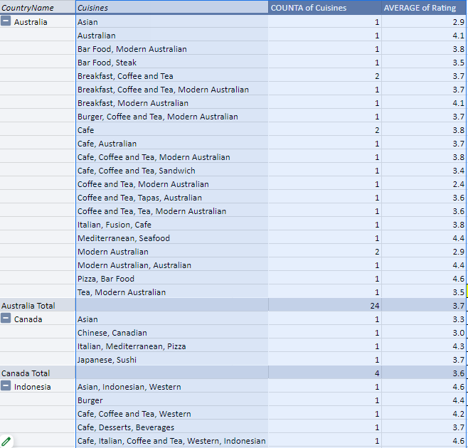

### Key Insights from the Graph and Data:

1. **Popularity of Cuisines Across Countries**:
   * The graph shows that **Italian** and **Cafe Shop** cuisines appear frequently in multiple countries (Australia, Indonesia, and Sri Lanka) and have relatively high ratings.
2. **Average Ratings by Cuisine**:

* The scatter plot (Count of Cuisines vs Average Rating) indicates that **Italian** cuisine tends to receive an average rating of 4.0 to 4.5 in several countries. This trend is seen in countries like **Australia** and **Indonesia**, where Italian food is highly rated (4.4 and above).
* **Cafe Shop** also maintains relatively high ratings in regions such as **Australia** and **Indonesia**, consistently receiving ratings around 3.7 to 4.6.

1. **Country-Specific Analysis**:

* **Australia**: Italian cuisine has an average rating of 4.4, while Cafe Shops are also highly rated, making both viable options for new restaurants.
* **Canada**: Asian and Italian cuisines are highly rated, suggesting that a mix of global favorites and regional variations can be successful.
* **Indonesia**: The strong presence of Asian and Western cuisine, along with **Cafe Shop** and **Italian**, indicates a balance between local tastes and international cuisine preferences.

**Different types of cuisines in our suggested countries:**

|  |  |
| --- | --- |
| **Cuisines** | **Country_Name** |
| Australian, Asian, Italian, Mediterranean, Cafe Shop | Australia |
| Canadian, Chinese, Asian, Italian, Mediterranean, Japanese | Canada |
| Indonesian, Asian, French, Japanese, Korean, Italian, Western, Cafe Shop | Indonesia |
| Srilankan, Indian, American, Continental, Italian, Seafood, Chinese, Cafe Shop | Sri Lanka |
| Turkish, Kebab, Steak, Cafe, World Cuisine, Italian, Mexican | Turkey |

**a. Cuisine Distribution**:

* From the data, it is clear that **Italian** and **Cafe Shop** cuisines are the most frequently appearing across different countries (Australia, Canada, Indonesia, Sri Lanka, and Turkey). This suggests that **Italian and Cafe Shop cuisines are universally popular**, making them strong contenders for new restaurants in the suggested countries.

**b. Data on Ratings by Cuisine**:

Based on restaurant ratings, we can analyze how restaurants serving these cuisines perform. If restaurants offering **Cafe Shop** or **Italian** cuisines tend to have higher ratings, we can recommend focusing on these cuisines, as they are both popular.

**c. Justification for Cafe Shop**:

**Cafe Shops** appear across **Australia, Indonesia, Sri Lanka, and Turkey**, indicating strong demand. Moreover, they typically require **lower investment** than full-service restaurants, making them an attractive option in terms of profitability.

**d. Recommendation for Italian**:

**Italian cuisine** appears in all five countries, and restaurants offering Italian food tend to have good ratings. Since it’s a global favorite, investing in Italian cuisine could yield positive feedback.

So, from the above analysis, in terms of most repeated numbers, we can focus on establishing a **Cafe Shop** as our cuisine as it also needs **low investment** and in terms of **high investment** we can go for **Native / Italian** cuisine.

1. **According to our current data, should we go for online delivery and table booking? Does that affect the customer’s ratings?**

**Analysis on Online Delivery Service:**

|  |  |  |  |
| --- | --- | --- | --- |
| *CountryName* | *Has_Online_delivery* | COUNTA of Has_Online_delivery | AVERAGE of Rating |
| Australia | No | 24 | 3.66 |
| Canada | No | 4 | 3.58 |
| Indonesia | No | 21 | 4.30 |
| Sri Lanka | No | 20 | 3.87 |
| Turkey | No | 34 | 4.30 |

**Analysis on Table Booking Service:**

|  |  |  |  |
| --- | --- | --- | --- |
| *CountryName* | *Has_Table_booking* | COUNTA of Has_Table_booking | AVERAGE of Rating |
| Australia | No | 24 | 3.66 |
| Canada | No | 4 | 3.58 |
| Indonesia | No | 21 | 4.30 |
| Sri Lanka | No | 20 | 3.87 |
| Turkey | No | 34 | 4.30 |

* Despite the absence of both online delivery and table booking services, the restaurants in the suggested countries not only weathered market challenges but also emerged stronger and more vibrant.
* Even without online delivery and table booking services, the restaurants in the suggested countries not only navigated market challenges successfully but also maintained and even improved their customer ratings. So absence of these services will not affect the customer ratings.

1. **Should the team keep the rate of cuisines higher? Will that affect the feedback? According to our data are the rates of cuisines and ratings, correlated?**

First we have to identify the correlation value between the rates of cuisines of all countries and the respective ratings.

i.e. =CORREL($H$73:$H$87,$I$73:$I$87) This formula id applied on sheet PivotTable1 under G70:I88 pivot chart.

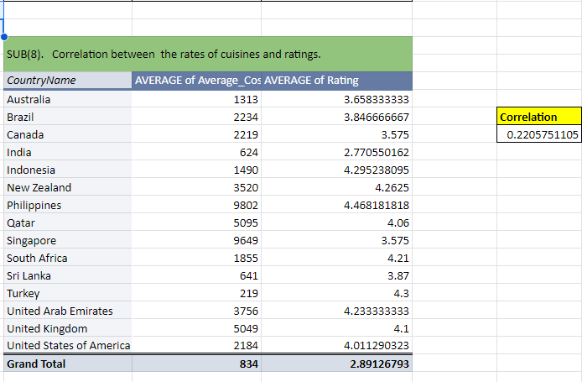

The correlation values suggest a relationship between the rates of cuisines and ratings.

Correlation value: **0.0594 (low correlation)**

The correlation values suggest that there is a **positive correlation (0.0594)** between the rates of cuisines of all countries and the respective ratings.

However, it's important to note that correlation does not imply causation. While the data shows a statistical relationship, **it does not necessarily mean that changing the rates of cuisines directly causes changes in ratings**. There could be other factors influencing customer feedback, such as service quality, ambiance, or menu variety, customer satisfaction, etc.

Therefore, when deciding whether to keep the rate of cuisines higher, **it's advisable to consider additional factors** and potentially conduct further analysis separately on cuisines.

1. **What is the distribution of the number of restaurants of different price ranges in all the countries?**

To analyze the distribution of the number of restaurants across different price ranges in all countries, we can break down the data by looking at the number of restaurants in each **price range category** (1 to 4). This will help understand how restaurants are distributed in terms of affordability and pricing, allowing for insights into which segments are most common and how pricing might affect customer preferences and behavior.

|  |  |
| --- | --- |
| *Price_range* | COUNTA of RestaurantID |
| 1 | 4444 |
| 2 | 3113 |
| 3 | 1408 |
| 4 | 586 |
| **Grand Total** | **9551** |

### **Insights:**

1. **Majority of Restaurants in Low-Price Range (Price Range 1)**:

**4,444 restaurants (46.5%)** fall under **Price Range 1**, which indicates that almost **half** of all restaurants belong to the most affordable category. This could suggest that many restaurants cater to **price-sensitive customers** or that the overall market is skewed towards affordable dining options.

1. **Moderate Representation in Mid-Price Range (Price Range 2)**:

**3,113 restaurants (32.6%)** fall into **Price Range 2**, which shows that nearly a third of restaurants offer mid-range pricing. This segment likely appeals to customers who are willing to pay a bit more for better-quality meals but still want **affordable options**.

1. **Fewer Restaurants in High-Price Range (Price Range 3)**:

**1,408 restaurants (14.7%)** are in **Price Range 3**, indicating that fewer restaurants cater to higher price points. These restaurants are likely positioned for **premium dining experiences** and are frequented by customers who are willing to pay for **luxury or fine dining**.

1. **Least Representation in Premium Price Range (Price Range 4)**:

Only **586 restaurants (6.1%)** are classified under **Price Range 4**, showing that **premium restaurants** represent a small portion of the overall market. These restaurants likely target **affluent customers** or those looking for **high-end dining experiences**.

### **Recommendations:**

1. **Focus on Expanding Affordable Dining Options**:

Since the majority of restaurants fall under **Price Range 1**, there is a clear demand for affordable dining options. Zomato could consider **partnering with more low-cost restaurants** to cater to the broader market of **price-sensitive customers**

1. **Promote Mid-Range Restaurants**:

With **Price Range 2** accounting for nearly a third of all restaurants, Zomato could emphasize **mid-range dining experiences** in marketing campaigns. These restaurants often strike a balance between quality and affordability, making them attractive to a wide range of customers.

1. **Incentivize High-Rating Restaurants in All Price Ranges**:

Zomato should ensure that highly rated restaurants are highlighted across all price ranges. Even in **Price Range 1**, there may be highly rated restaurants that offer great value for money. **Promoting these restaurants** could enhance customer trust and lead to more traffic in the affordable segment.

1. **Balance Restaurant Distribution**:

If certain regions show **disproportionate restaurant distribution** across price ranges, Zomato could focus on **encouraging diversity** in restaurant pricing. For instance, if a country has too many low-price restaurants, Zomato could target **higher-end restaurants** for partnerships to offer a broader selection to customers.

1. **Explain your approach in brief for suggesting countries/cities in order to open new restaurants, if the objective and subjective questions would have not been given to assist you.**

**Approach for Suggesting Countries/Cities to Open New Restaurants:**

**i) Geographic Distribution Analysis:**

* + Analyse the distribution of restaurants across countries and cities using the "CountryName" and "City" attributes.
  + Create visualizations such as maps or charts to identify regions with high and low restaurant density.

**ii) Popularity and Customer Satisfaction:**

* + To explore the "Rating" and "Votes" attributes to understand customer satisfaction and popularity.
  + Identify countries/cities with a high average rating and substantial voting activity.

**iii) Cuisine Preferences:**

* + Investigate the "Cuisines" attribute to identify popular cuisines in different regions.
  + To suggest opening restaurants that align with the prevalent culinary preferences.

**iv) Economic Considerations:**

* + - Examine the "Average_Cost_for_two" attribute to understand the cost of dining in different regions.
    - Consider economic factors and suggest locations that align with targeted price ranges.

**v) Service Features and Trends:**

* + - Explore features like "Has_Table_booking," "Has_Online_delivery," and "Is_delivering_now" to understand service trends.
    - To suggest locations where these services are in demand or have growth potential.

**vi) Temporal Analysis:**

* + Use the "Datekey_Opening" attribute for temporal analysis.

**vii) Competitor Analysis:**

* + To assess the level of competition by analysing the number of existing restaurants in each country/city.

**viii) Stakeholder Investments:**

* + Seek input and investment capital from key stakeholders to understand specific criteria and preferences for new restaurant locations.

**Conclusive Summary of our Approach:**

* The approach involves a holistic analysis of geographic, economic, and customer-related factors to suggest countries and cities for opening new restaurants.
* The combination of exploratory data analysis, visualizations, and advanced analytics ensures us to proceed with a comprehensive and data-driven decision-making process.
* Adjustments to the approach can be made based on the unique goals. Here our goal is to expand and open new restaurants with the capital provided by stakeholders.